Soft Skill Assignment

**Module 2: Campus to Corporate :-**

**Task 1**: Build your Resume

• Create a professional resume using a clean, structured format that highlights your

skills, education, and achievements.

• Include the following sections: Personal Info, Objective, Education, Skills,

Experience, Projects, Certifications, and Interests.

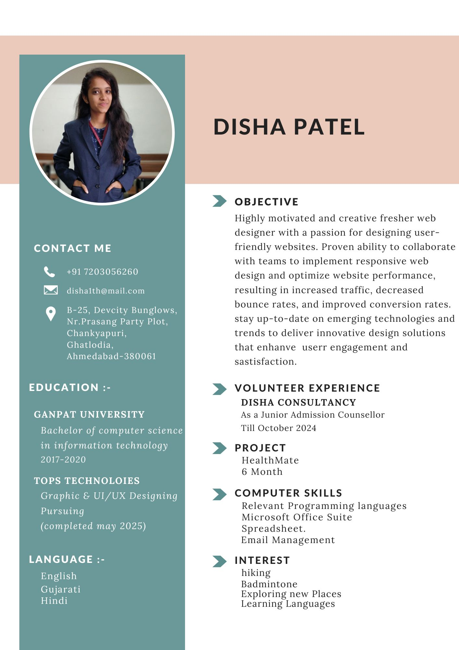

**Task 2**: LinkedIn Profile

• Create or update your LinkedIn profile to reflect your resume.

• Ensure your profile picture, headline, and summary are professional and complete all

sections: Experience, Skills, and Certifications.

LinkedIn Profile Link :-

<https://www.linkedin.com/in/disha-patel-7579331b8>